HTTP Server Configuration

1. Install http packages & dependencies as shown below-



2. Start & enable httpd service-



3. Check the service status-

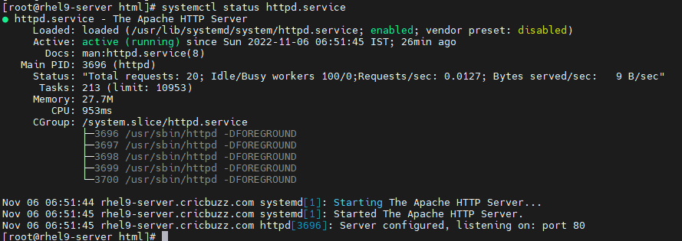

4. Add http & https service in firewall-

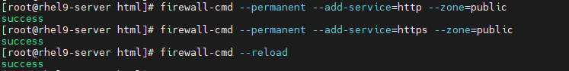

5. Now create (If not any) & edit index.html file in /var/www/html directory-





6. Go to client machine & open website with this server’s IP first-

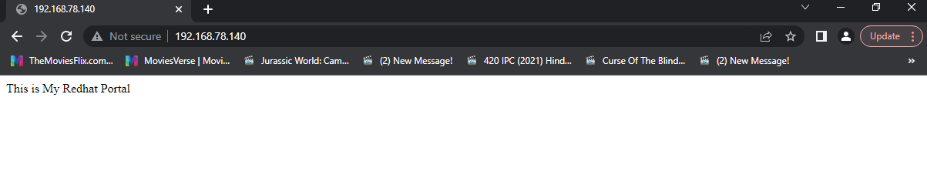

7. To access it using Fully qualified domain name, DNS server must be setup at server side & add DNS server IP in client’s DNS-

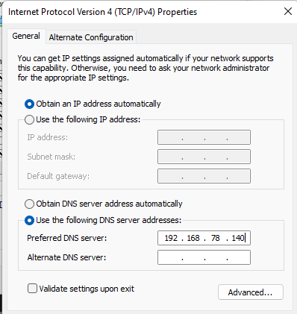

8. Check server FQDN using hostnamectl-



8. Now access website using name in place of IP-

